NATIONAL UNIVERSITY OF COMPUTER AND EMERGING SCIENCES

(KARACHI CAMPUS)

FAST School of Computing

**Fall 2023**



 

**Topic:** Art House – an online marketplace for art

**Instructor:** Ms. Abeeha Sattar

**Date of submission:** 05/12/2023

**Presented by:**

* Muhammad Kamran 20k-0269
* Bilal Ahmed Khan 20k-0183
* Lailumah Hiba Nadeem 20k-0431
* Bilal Shahid 20k-0173

**Introduction:**

The "Art House" project, a collaborative effort by our team, aims to revolutionize the online art marketplace by creating a dynamic platform connecting artists with potential buyers. Developed using ASP.NET MVC 5, Entity Framework, and PostgreSQL database, this project aligns with modern technologies, as proposed in our project outline.

**Project Overview:**

Art House strives to provide a seamless space for artists to showcase and manage their artwork while allowing buyers to explore and connect with artists effortlessly. The platform promotes independent discussions and transactions between artists and buyers, fostering a vibrant and dynamic art community.

**Features Implemented:**

Our team has successfully implemented a range of features, carefully aligning with the proposed functionalities:

* SignUp and Login functionality
* Paintings distributed into Categories and Sub Categories
* Checkout Functionality
* Ability to add multiple items to cart
* Search Functionality to find available paintings in the catalog
* Ability to update details post signup (Like changing address, password etc)

**Technology Stack:**

To ensure a robust and modern development approach, we employed the following technology stack:

* Frontend: HTML, CSS, and JavaScript collectively contribute to a responsive and visually appealing user interface.
* Database: SQL Database serves as the backbone of the project, offering a reliable foundation for data storage and retrieval. We deployed the database on Microsoft Azure using the Azure SQL Database service.
* APIs: ASP.NET is utilized to develop APIs, facilitating seamless communication between the frontend and the database.

**Screenshots of Website:**

* Homepage-1

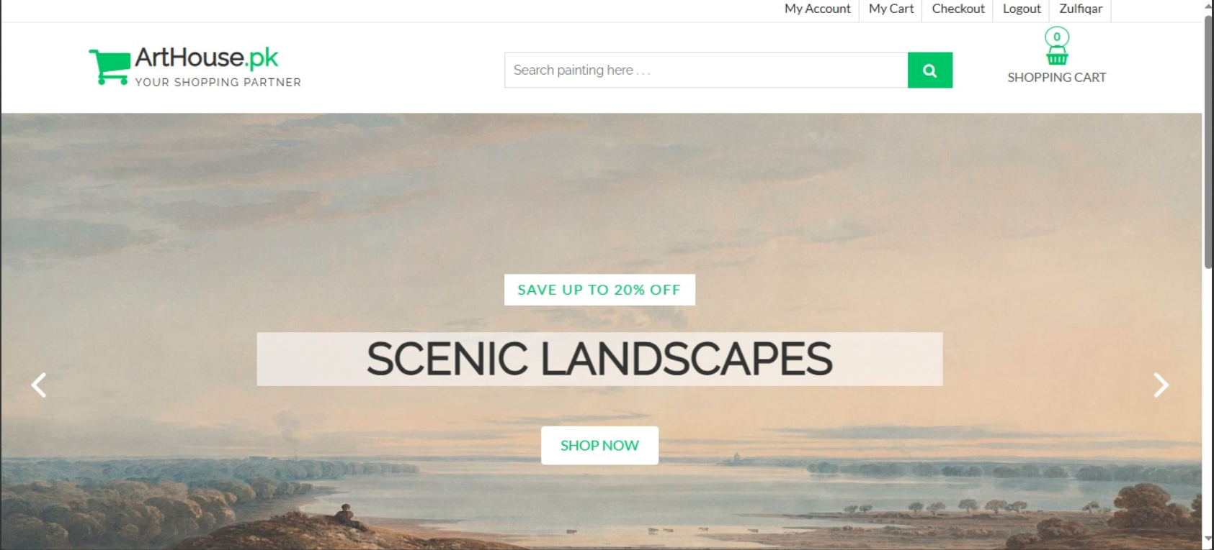

* Homepage-2

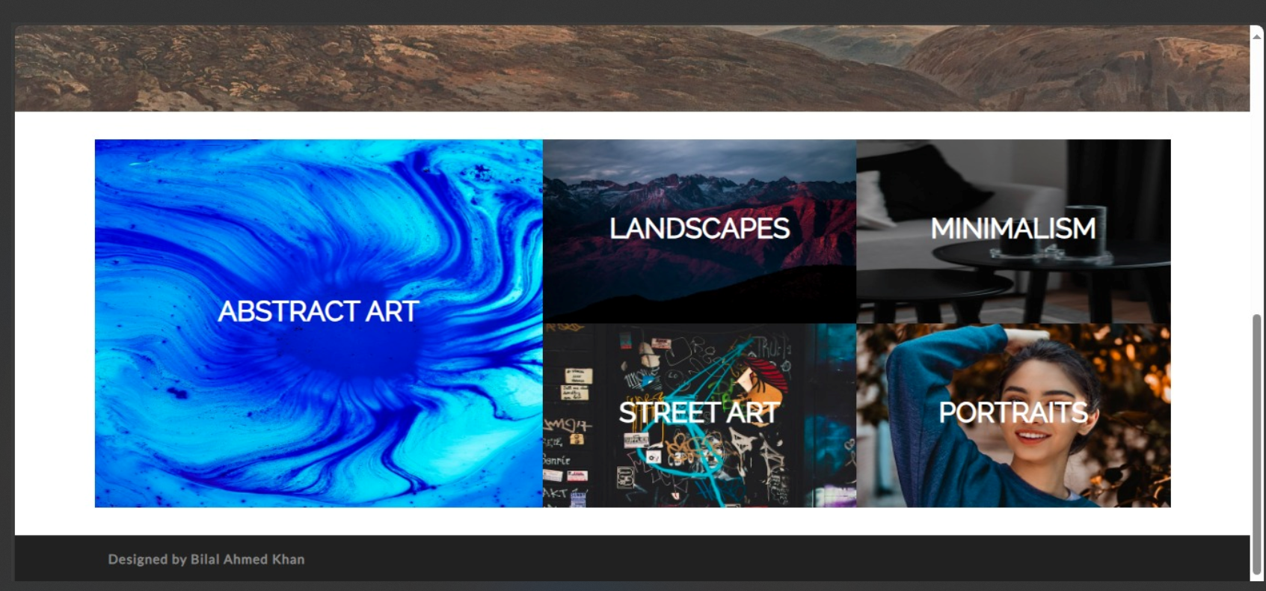

* Search functionality

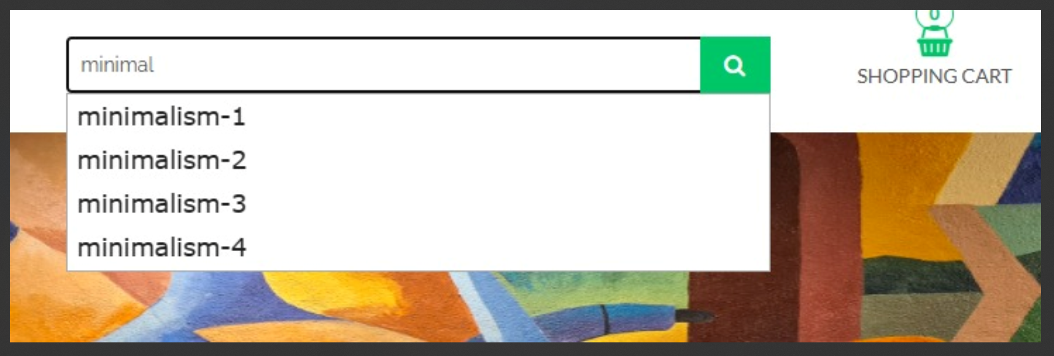

* Login

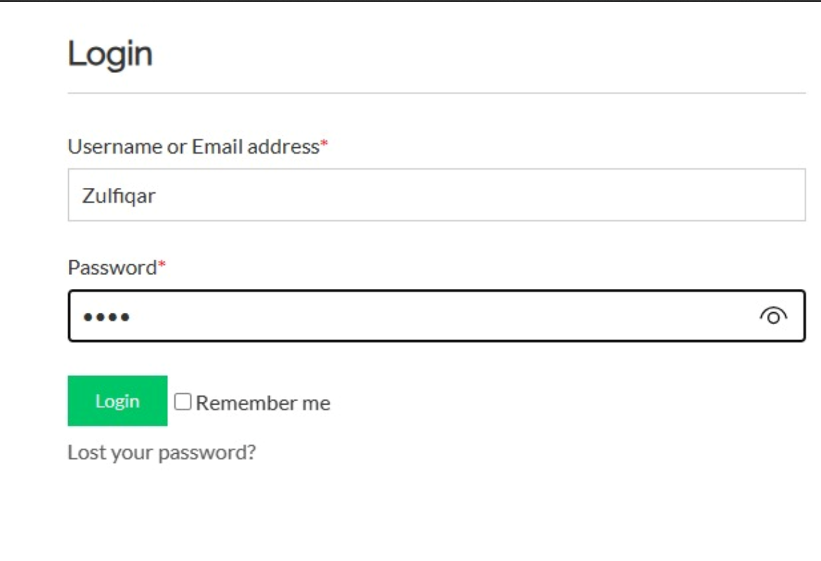

* Shopping Cart showing selected items



* Checkout Page

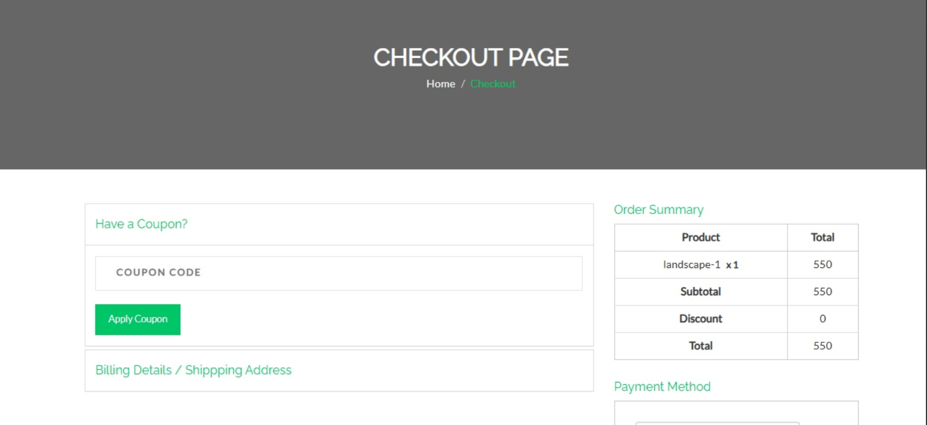

* Billing Details

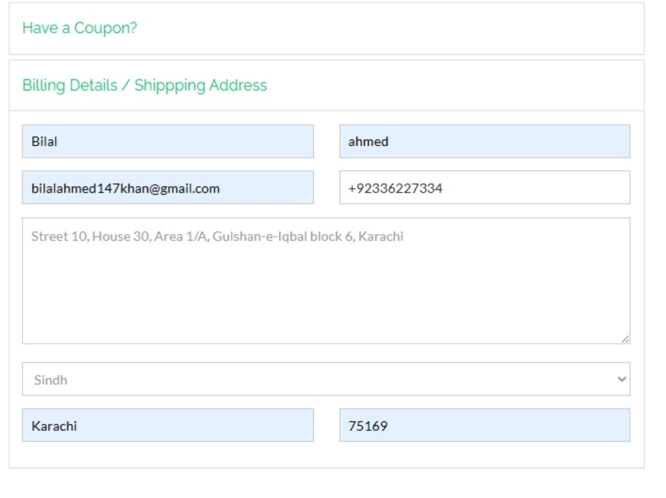

* Order Placed Successfully Screen



* Categories and Subcategories

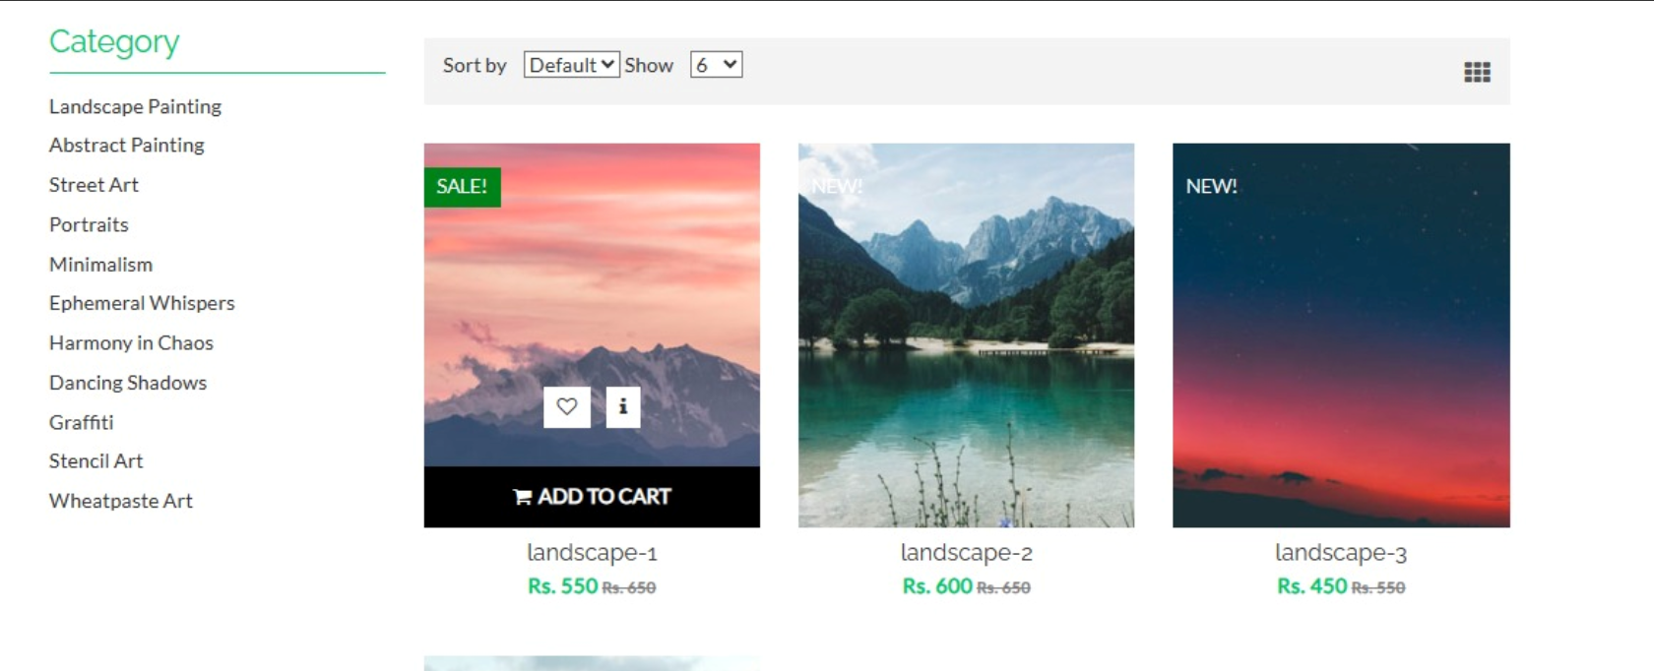

**Conclusion:**

In conclusion, Art House successfully materializes the vision outlined in our proposal, creating a user-centric online marketplace for art. The implemented features empower artists and buyers, fostering a dynamic and creative community. We believe Art House has the potential to reshape the way artists connect with their audience and buyers discover unique pieces of art.

This project report serves as a testament to our commitment to excellence and innovation in the realm of online art marketplaces.